

# ONLINE PORTFOLIO



O u s s a m a B e n O m a r E l M d a g h r i



G a m e

D e v e l o p e r

<

/>



Table of Content

**Table**

1 - S

2 -

## of content:

### KILL SUMMARY JOB AD

1. **-** RESUME

### - COVER LETTER

1. - RECOMMENDATION
2. - ARTIFACTS



**About Me**

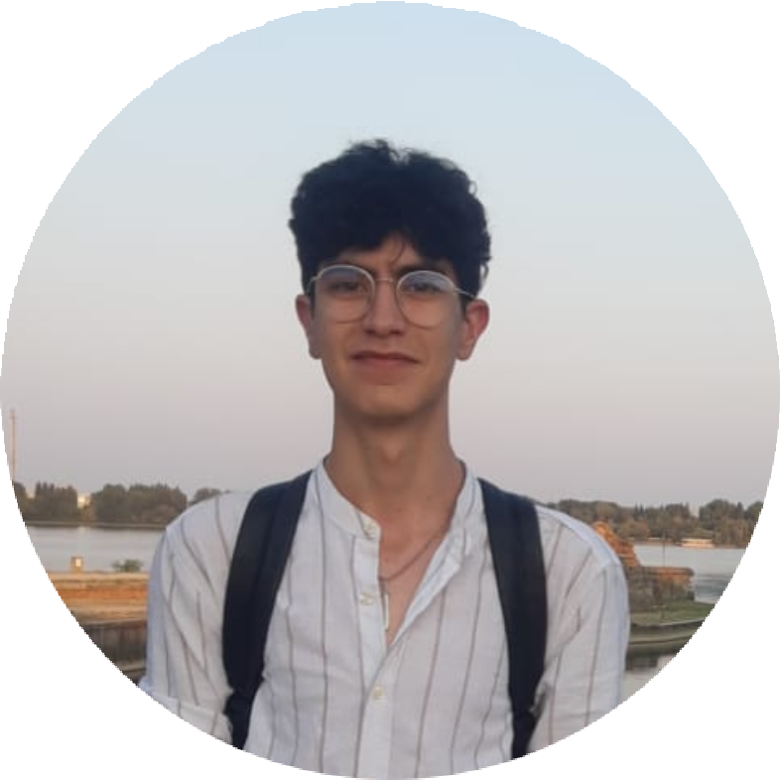

Passionate about new technologies and video game development, I am extremely motivated to constantly develop my technical, professional and relational skills. I am confident in my capacity for adaptaff Iffy communicaton and responsibfity to ensure the achievement of any Intended purpose Ina firnely, effective and efficient manner.

**Technical Skill**

Unity Development

Object-Oriented Design

Flutter

Design Patterns

Android Development

React Native

Photoshop

Illustratore

**Programming Languages:**

**Oussama Ben Omar El Mdaghri**

Java

Python

HTML/CSS/JS

C/C#/C++

SQL/PLSQL

Dart



**Title:**

Job Ad

**Software Engineer/Android**

#### Role:

We are looking for a product focused engineer to join our Android team. The team is responsible for all Android apps that are involved with a delivery, namely the Customers app and Courier app. These apps are essential components of our product: helping customers order the delicious food they want and acting as communication channels and sensors to measure and understand how to improve our service.

#### URL:

[http://hire.jobvite.com/CompanyJobs/Careers.aspx? k=Job&c=q8Z9VfwV&j=oKLU0fw9&s=Indeed](http://hire.jobvite.com/CompanyJobs/Careers.aspx?k=Job&c=q8Z9VfwV&j=oKLU0fw9&s=Indeed)

#### Responsibilities:

·Work closely with productmanagement, design, marketingand Courier teams to understand needs and determinesolutions to improvingoperations and end-userexperience.

·Go out on deliveries to understand your audience and build productsto solve their needs.

·Have direct impacton delivery times,profit margins and customers - both internaland external.

·Have the opportunity to explore and build featuresacross the entiretechnical stack, from the databaseall the way to the client.

·Apply the most cutting edge technology as it’s developed to innovatively solve problems (Android Auto integration?).

·Work with a team of world classAndroid engineers and contributors to open sourceprojects like Mortar,Flow and RxJava.

#### Skills:

·Strong knowledge of CS fundamentals and code organization.

·Experience in or desire to learn Androidand Java.

·Experience using the Google Maps for Android APIs is a strong plus.

·Experience with Bluetooth and peripherals is a plus.

·Apps already launchedon the Play store is a plus

·Experience with Railsand Web Development is also a plus.

·Computer Science or other technical degree helpful.

**Experience:**

**Projects:**

Resume

GEOJAM 2022 submission:

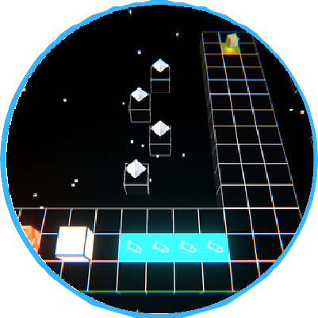

**3D puzzle game where you control a cube which can collect power ups in each side and use them to solve challenging puzzles. Ranked 21st/260 games on gameplay and 30th/260 overall.**

Flutter APP for university student engagment:



**2D puzzle game where the player's goal is to collect musical instruments in each area of the game by solving puzzles related to rotation of tiles.**

#### Education:

##### Bachelor in Computer Science at Al Akhawayn

**University / 2020 - 2024**

**Part-time android developer at Al Akhawayn University:**

**Technologies used are:**

**-Flutter for first version of the app**

**-React Native currently**

**The mobile application's goal is to increase student engagement by making challenges linked to events happening in the university and offering points as a reward for completion; which can be used to redeem prizes.**

**Technical Skill**

Unity Development

Object-Oriented Design

Flutter

Design Patterns

Android Development

React Native

Illustratore

Photoshop

**Programming Languages:**

Java

C/C#/C++

Dart

SQL/PLSQL

Python

HTML/CSS/JS

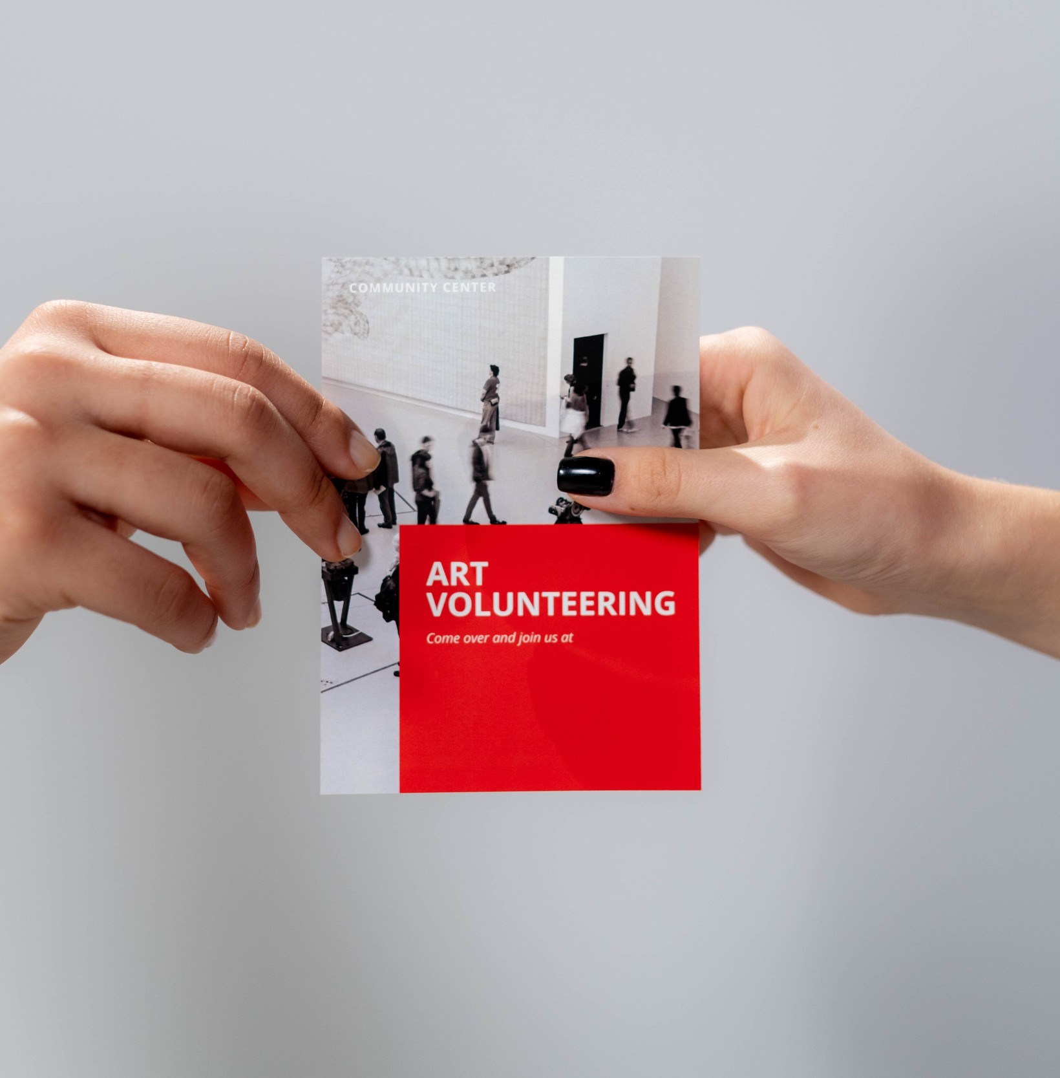

Flyer Design

## Flyer Design

###### Lorem ipsum dolor sit amet, consectetur adipiscing elit. Sed aliquet condimentum dapibus. Praesent tincidunt condimentum risus, at sagittis arcu dignissim quis. Pellentesque convallis ante sit.

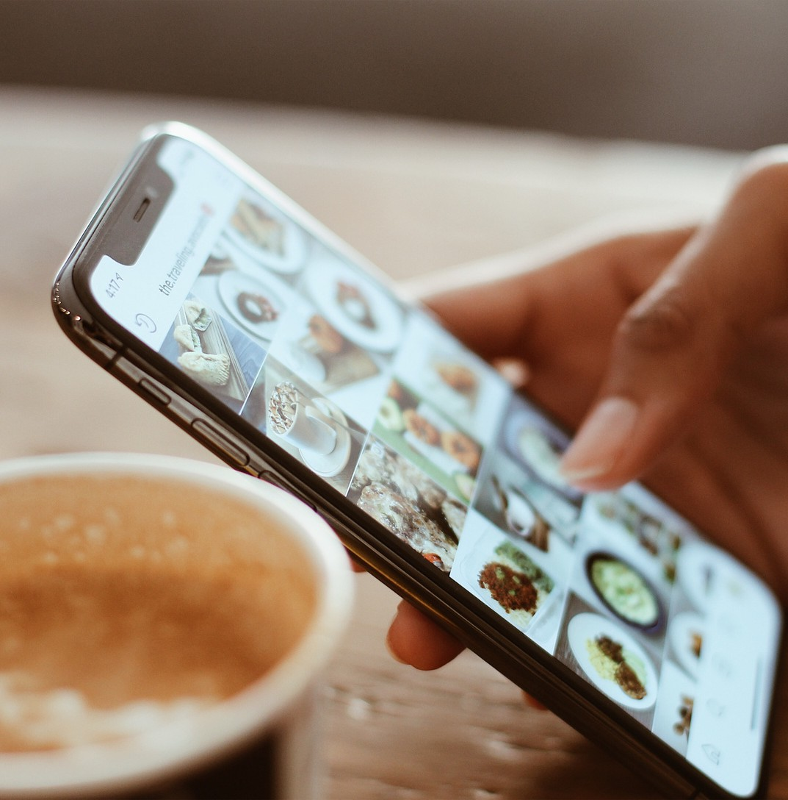

Social Media Design

## Social Media Design

###### Lorem ipsum dolor sit amet, consectetur adipiscing elit. Sed aliquet condimentum dapibus. Praesent tincidunt condimentum risus, at sagittis arcu dignissim quis. Pellentesque convallis ante sit.



Visual Identity

## Visual Identity

###### Lorem ipsum dolor sit amet, consectetur adipiscing elit. Sed aliquet condimentum dapibus. Praesent tincidunt condimentum risus, at sagittis arcu dignissim quis. Pellentesque convallis ante sit.



Logo Design



## Brand Logo Design

###### Lorem ipsum dolor sit amet, consectetur adipiscing elit. Sed aliquet condimentum dapibus. Praesent tincidunt condimentum ris s, at sagittis arcu dignissim quis. Pellentesque convallis ant sit.

A r t & D e s i g n P o r t f o l i o

# THANK YOU

+123-456-7890

[www.reallygreatsite.com](http://www.reallygreatsite.com/)

UI / UX Design

[hello@reallygreatsite.com](mailto:hello@reallygreatsite.com)

@reallygreatsite

B a r t h o l o m e w H e n d e r s o n